**Day 1 Lab Assignments**

1. Design your home page (Or your CV page) using the following layout (and make sure that it’s completely responsive):
2. Make you page fully responsive (use viewport meta tag).
3. DON’T use tables in you layout, use divs & spans (or new HTML 5 structural elements), with CSS instead.
4. Use flexbox instead of floating.
5. Make you images, Video responsive (use max-width property).

|  |  |  |
| --- | --- | --- |
| **Website Logo (Image)** | | |
| **< ~ Navigation bar ~ >**  **(containing** [**home**](Day2_Lab%20Assignment.docx)**,** [**contact us**](Day2_Lab%20Assignment.docx)**,** [**about**](Day2_Lab%20Assignment.docx) **links)** | | |
| Login box in div containing user name, password text boxes and login button (image Button).Make a border to div  **My Pages online**  C:\Users\HANY\Desktop\ITI\Intake 30\Materials & Technical\Foundation\HTML\For Students\Lects' Material & Labs' Assignments\Day 1\Lab_assignment\facebook.jpg  [http://t0.gstatic.com/images?q=tbn:KWnUHV7BuzcZgM%3Ahttp://www.wyso.org/wyso/media/twitter_icon2.png](http://images.google.com.eg/imgres?imgurl=http://www.wyso.org/wyso/media/twitter_icon2.png&imgrefurl=http://www.wyso.org/&usg=__ri3Hfcwt6K6_uwpKFESA7yaVLuQ=&h=256&w=256&sz=27&hl=ar&start=3&sig2=PBIriaX2RBhrSNpTpTLQcA&um=1&tbnid=KWnUHV7BuzcZgM:&tbnh=111&tbnw=111&prev=/images?q=twitter+icon&hl=ar&rlz=1W1ADFA_en&um=1&ei=8hZMS-CSMtP84Abn6oDlDQ)  Video Tag | **My Profile**   * Name: * Age: * Address: * Phones: * Faculty: ([your faculty name as link to its website](Day2_Lab%20Assignment.docx)) * Hobbies    * Mail: Link [mail to your mail.](Day2_Lab%20Assignment.docx) | Personal Photo  News bar |
| **Copyrights © are reserved to ITI.** | | |

1. Use Media query and CSS breakpoints your website layout on normal laptops and PCs, tablets and smart phones:
   1. Hide the right column on tablet size (and make the middle part fill the width), and hide both right and left on smart phones. (Use media queries on CSS file and breakpoints).
   2. When you hide the right or the left columns, make them appear as rows (width 100%) above the footer (show each one below the content when you hide it).
   3. Hide the navigation bar (or change its style to be vertical), in width less than 450px (Use media query on CSS style, not CSS file.
2. Use grid layout with your CV page design, and make sure that it’s completely responsive (use viewport meta tag):
   1. Use 16 columns layout.
   2. Set box-sizing property.
   3. Use Viewport units with the text in the header, and max-width with the image.
   4. Use float property.
   5. Use flex instead of float (**Bonus**).

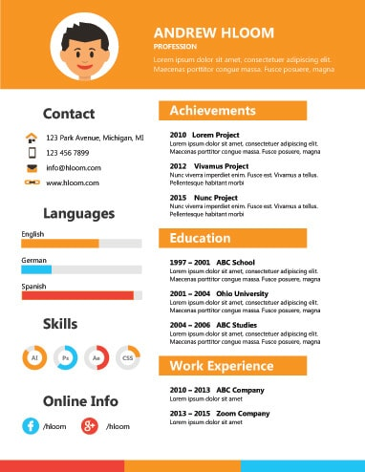

**<Thank>YOU </Thank>**